Committee | COUNCIL MEETING
Date | 10 July 2023
Agenda Item | 12

To note the Essex Electric Vehicle Charge Point Strategy

Recommendations:
- That HTC notes the charge point strategy
- That it selects new sites for new installations of chargepoints – The previous council had already identified Butler Road and Courtaulds
- That it agrees to promote and publicise the strategy as part of its Climate Action


Sarah Greatorex Town Clerk

Essex Electric Vehicle Charge Point Strategy
Communications toolkit

Background
In Essex, around half (49%) of CO₂e emissions are from transport and it is the largest contributor to poor air quality across any economic sector. Over half of these emissions come from cars and a third from heavy and light goods vehicles.
Responding to the climate crisis, Essex County Council has committed to reducing the county's greenhouse gas emissions to net zero by 2050, in line with UK statutory commitments. Alongside this, the Government is phasing out the sale of new petrol and diesel cars by 2030 and plug-in hybrid vehicles by 2035 to accelerate the transition towards all new vehicles being zero emission.
Switching to electric vehicles (EV) will help contribute to the net zero goal and improve air quality, but to make this a reality and aid EV growth in the county, people need access to a reliable, convenient, accessible, and fairly priced network of EV charge points.
The Essex Electric Vehicle Charge Point Strategy aims to support this by setting out how Essex County Council will work with local authority partners and the private sector to enable the delivery of changing points in key locations to maximise use – delivering the “the Right Charger in the Right Place”.
The strategy looks at an initial 2-3 year timeframe (up to 2025) to specifically address charging infrastructure for EVs, with the intention to deliver further strategies in the future.
Key stats -
- There is potential for 50,000 EVs in Essex by 2025, rising to 220,000 by 2030
- There are currently 300 registered public charge points in the county. It is predicted we will need a minimum of 1,500 by 2025, rising to 6,000 by 2030
- The projected increase in uptake of EVs could reduce car and van CO₂e emissions in Essex by around 70% by 2040.
To support the development of the strategy, it has now reached a stage at which we would welcome views to help refine it further.
Where to find out more -
You can read more about the strategy on the scheme webpage: www.essexhighways.org/ev-strategy.
Our project team can be contacted at ElectricVehicleStrategy@essexhighways.org

How you can help

We are launching a public consultation for the Essex Electric Vehicle Charge Point Strategy on Thursday 15 June 2023 to coincide with Clean Air Day – the UK's largest air pollution campaign.

The consultation will close on Sunday 30 July 2023.
You can help us in a number of ways:
Promotion of the consultation – Please promote participation in the charge point strategy consultation to the public across your channels.
In this toolkit, you will find the following content:
- Newsletter/website/emails
- Social media
- Press release
- Animation video and images
Please edit the written content, as required, to suit your house style and different channels and audiences.
As a countywide consultation, we will be undertaking a programme of advertising, but any additional support to amplify the consultation through your channels would be appreciated.
Please don’t hesitate to contact us at ElectricVehicleStrategy@essexhighways.org if you need more information or content.
Share internally – We recognise that your authority may also wish to consider/formally respond to the consultation and would welcome this. Please share information with any teams/officers internally for whom it may be relevant.
Share with councillors/your networks – Please share the strategy and consultation details with your councillors and other groups/networks (businesses groups/citizen panels etc.) for whom it may be relevant. Alternatively, please let us know of any specific stakeholders in your area who you feel we should contact.

Newsletter/website/emails

The Government has set out plans to reduce carbon on our roads by phasing out the sale of new petrol and diesel cars and vans by 2030.

Alongside this, Essex County Council has committed to reducing greenhouse gas emissions to net zero by 2050 to help tackle climate change. (add in your own council commitments)
In Essex, around half of all CO₂e emissions are from transport and a shift towards electric vehicles is an important part of achieving the net zero goal and improving air quality, alongside the continued work to encourage more sustainable transport options.
Essex has already seen a significant increase in the ownership of plug-in vehicles in recent years and there are over 300 registered public charging points.
However, as we continue to make this shift, we need to go further, and it is predicted we will need up to 6,000 public charge points across the county by 2030.
Essex can lead the way in shifting to safer, greener, healthier travel, but to do so, residents, businesses and visitors need access to a reliable, convenient, accessible and fairly priced network of electric vehicle charging points.
Essex County Council’s Electric Vehicle Charge Point Strategy is the first step in making this happen, setting out a simple vision – the Right Charger in the Right Place.
Your views on the draft strategy are important and your feedback will help further shape the strategy before it is formally launched.
To find out more and have your say, please visit: www.essexhighways.org/ev-strategy.

Social media posts

Sample Facebook / Instagram posts | Suggested images (hi-res versions available from file transfer)
Idea 1 (at consultation launch)  In Essex, half of CO₂e emissions come from transport.  As we move away from petrol and diesel cars, we recognise the need for a reliable, convenient, accessible and fairly priced network of electric vehicle charging points across the county.  There are currently 300 registered public charge points in Essex, but it is predicted we will need a minimum of 1,500 by 2025, rising to 6,000 by 2030.  To support this, a new countywide strategy has been created, setting out plans for how to deliver ‘the Right Charger in the Right Place’.  Your views on the draft strategy are important and Essex County Council is currently running a public consultation.  To find out more and have your say, visit: www.essexhighways.org/ev-strategy | 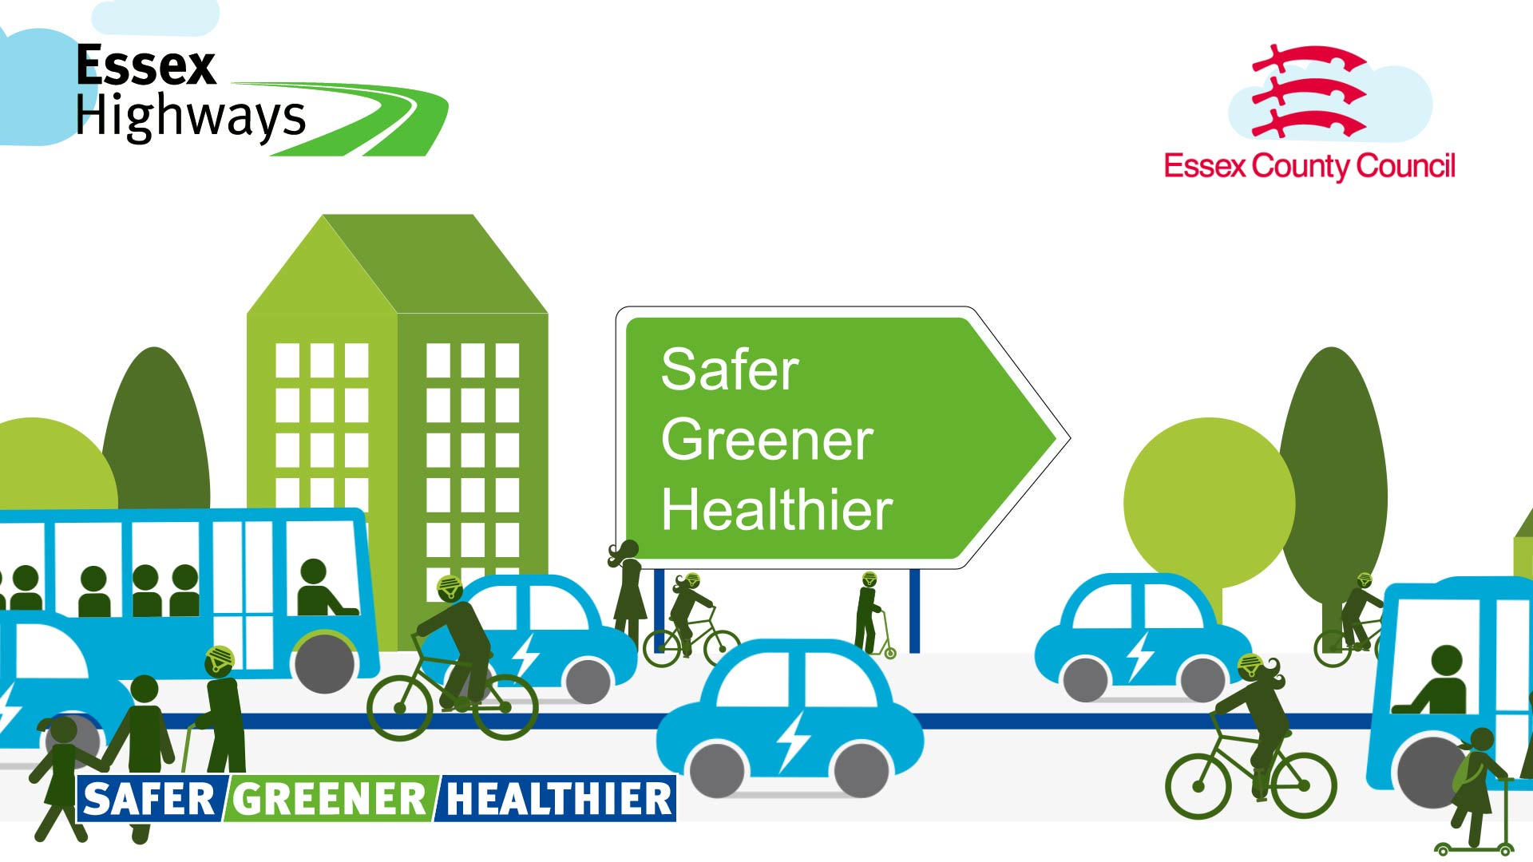  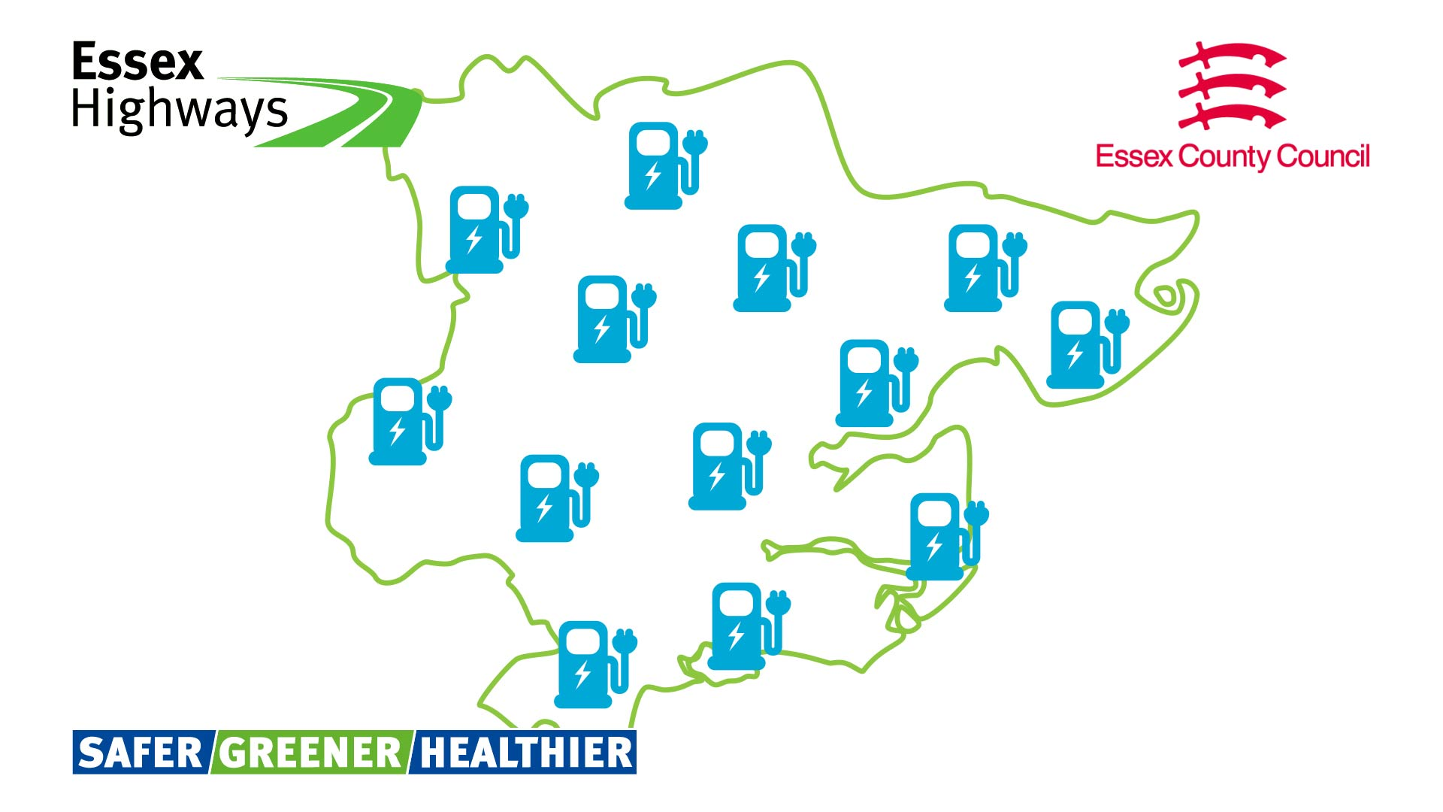
Idea 2 (during consultation)  Have your say on the new Essex Electric Vehicle Charge Point Strategy.  Did you know that electric vehicle ownership has quadrupled in recent years?  There are currently about 300 registered public charge points in the county. However, it is predicted 6,000 will be needed by 2030.  To support this, a countywide strategy is being developed, setting out plans for how to deliver ‘the Right Charger in the Right Place’.  Your views on the draft strategy are important and Essex County Council is currently running a public consultation.  To find out more and have your say, visit: www.essexhighways.org/ev-strategy | 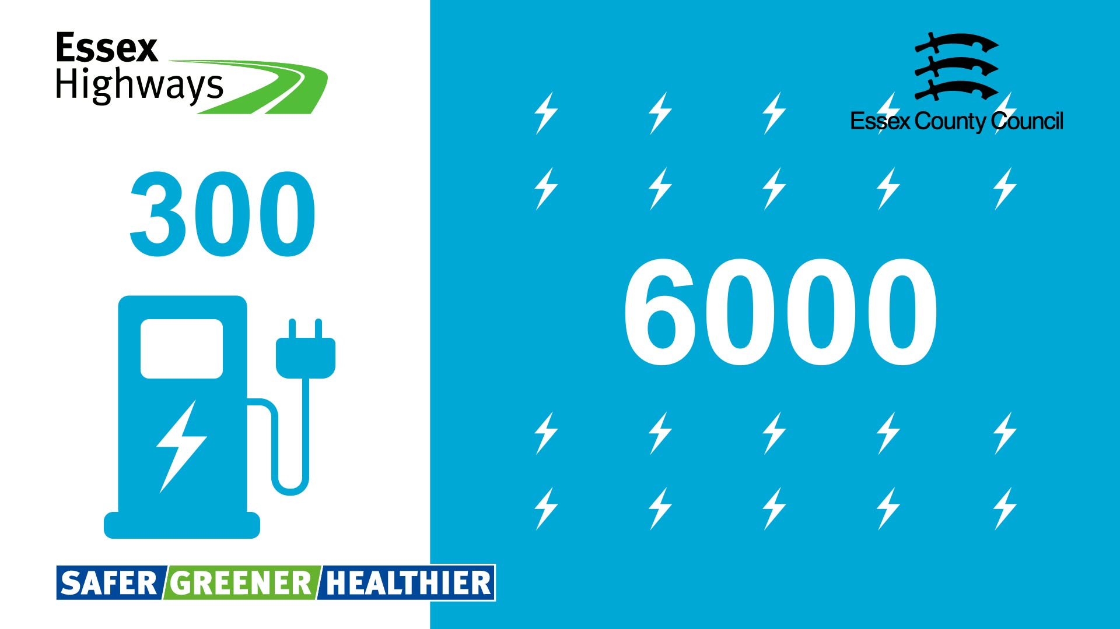
Idea 3 (during consultation)  In Essex, around half of CO₂e emissions are from transport.  With local councils committing to reducing the county's greenhouse gas emissions and the Government phasing out the sale of new petrol and diesel cars, electric vehicles have a significant part to play.  Switching to electric vehicles will make a significant difference and could reduce car and van CO₂e emissions in Essex by around 70% by 2040.  But the county needs a reliable, convenient, accessible, and fairly priced network of EV charge points.  To support this, a new countywide strategy has been created, setting out plans for how to deliver ‘the Right Charger in the Right Place’.  Your views on the draft strategy are important and Essex County Council is currently running a public consultation.  To find out more and have your say, visit: www.essexhighways.org/ev-strategy | 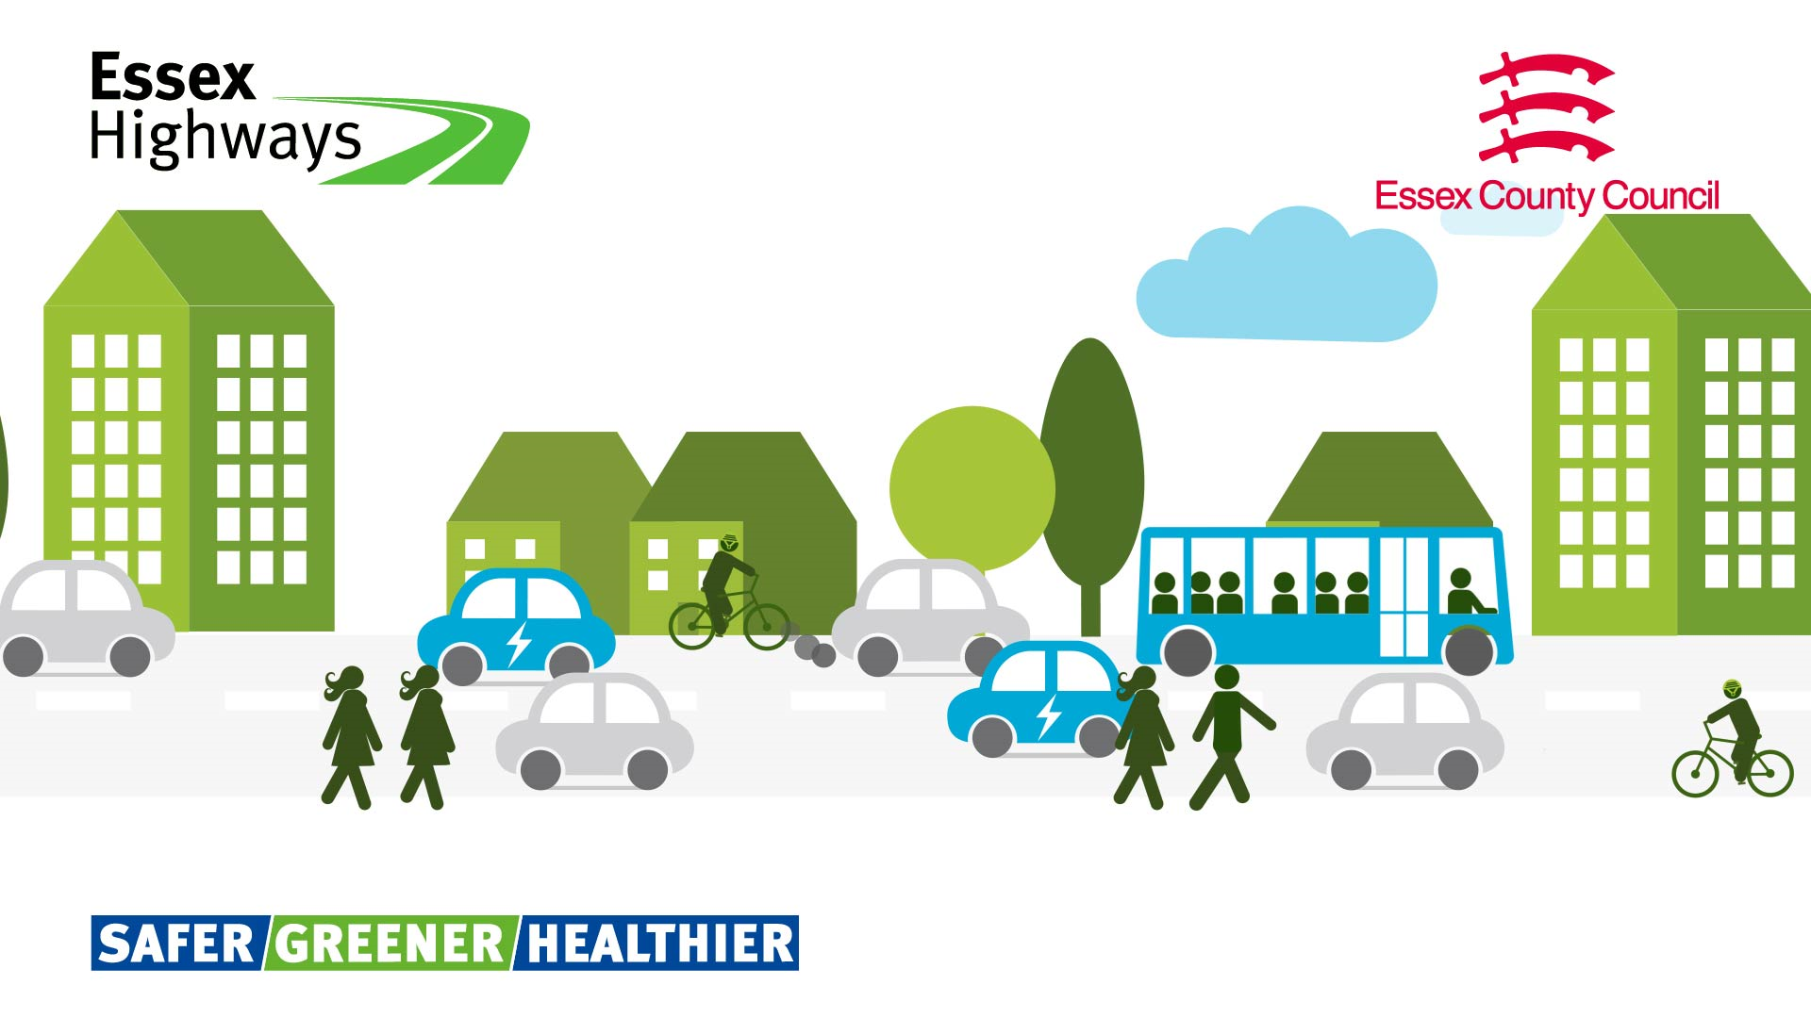
Idea 4 (near the end of the consultation)  It’s your last chance to have your say on the Essex Electric Vehicle Charge Point Strategy.  Did you know the expected uptake in electric vehicles could reduce car and van CO₂e emissions in Essex by around 70% by 2040?  To make this a reality, we need a reliable, convenient, accessible and fairly priced network of electric vehicle charging points across the county.  Essex County Council is currently running a public consultation on its draft Essex Electric Vehicle Charge Point Strategy which closes on Sunday 30 July.  Your feedback will help further shape the strategy before it is formally launched.  To find out more and have your say, visit: www.essexhighways.org/ev-strategy | 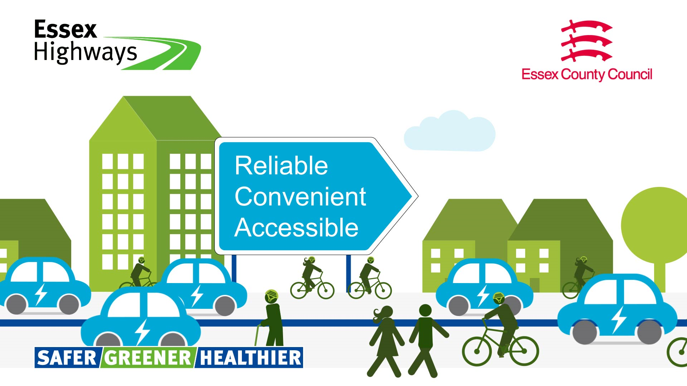

Sample Tweets
Idea 1 (at consultation launch): In Essex, half of CO₂ emissions are from transport. As we move away from petrol and diesel cars, access to a network of electric vehicle chargers across the county is vital. Have your say on the new Essex Electric Vehicle Charge Point Strategy at: www.essexhighways.org/ev-strategy
Idea 2 (during consultation): Did you know that electric vehicle ownership has quadrupled in recent years? Predictions are we need a minimum of 1,500 public charge points by 2025. Have your say on the new EV charge point strategy for the county at: www.essexhighways.org/ev-strategy
Idea 3 (near the end of the consultation): It is your last chance to have your say on the Essex Electric Vehicle Charge Point Strategy, which focuses on delivering a reliable, convenient, accessible and fairly priced network of electric vehicle charge points across the county. Visit: www.essexhighways.org/ev-strategy

Press release

Clean Air Day 2023 sees consultation on electric vehicle charging network launch in Essex

New strategy aims to grow county’s electric vehicle charging network and improve air quality in Essex.

Essex County Council has launched a six-week consultation on a new Essex Electric Vehicle Charge Point Strategy. Residents and businesses are invited to take part from today, 15 June.

The launch of the consultation coincides with Clean Air Day, the UK’s largest air pollution campaign.

It also runs alongside the council’s Safer, Greener, Healthier campaign which aims to encourage sustainable transport options, such as walking, cycling and bus travel.

Due to the rise in electric vehicles in Essex, the strategy aims to improve access to charging points and help improve air quality.

Electric vehicles play an important role in reducing emissions, improving air quality and achieving its net zero goals.

The new strategy focuses on a simple vision of providing the ‘right charger in the right place’. It sets out a plan to ensure residents, businesses and visitors to Essex can access a high-quality electric vehicle charging network.

Councillor Lee Scott, Cabinet Member for Highways Maintenance and Sustainable Transport said: “In Essex, around half of all CO₂ emissions are from transport. Supporting the shift towards electric vehicles will be really important in achieving our net zero goals and improving air quality in the county.

“If the current trend continues, about 70 per cent of car and van CO₂ emissions could be cut by 2040 through switching to electric vehicles. We cannot let infrastructure be a barrier to achieving that.

“We know transitioning to electric vehicles will only get us so far towards decarbonising road traffic. We are working hard to create a Safer, Greener and Healthier Essex by reducing the need to travel and encouraging people to shift their journeys to sustainable options.”

There are already 300 registered public charging points for electric vehicles in the county, but the demand is expected to grow significantly over the coming years.

Councillor Scott added: “We want Essex to lead the way and have set out a very simple vision, the right charger in the right place. We predict we will need up to 6,000 public charge points in the county by 2030.

"These charge points will mainly be delivered by the private sector, but we also have a really important role in setting out what we want the electric vehicle charging network to look like. This will ensure no part of the county is left behind.

“By 2030, we want residents, businesses, and visitors to have access to a reliable, easy-to-use, safe, and fairly priced network across Essex.“
The public consultation on the strategy is open until 30 July. For more information and to have your say, please visit www.essexhighways.org/ev-strategy.

ENDS

Notes

Essex County Council is involved in a number of other projects and initiatives to improve air quality in the county.

The council is working alongside the county’s district, borough and city councils as part of the Essex Air Consortium.

It is currently developing a draft Essex Air Quality Strategy, which the public will be consulted on later this year.

It will also soon be launching a new Essex Air website.

